Week 2 Metrics Insight Report: Telemetry Signal Corruption & True Process Stability

- Systemic Telemetry Signal Corruption
Our raw industrial sensor network has been transmitting deeply corrupted data streams that paint an alarming, entirely inaccurate picture of plant performance. Uncleaned telemetry outputs from the past week indicated massive, random pressure spikes reaching as high as 15,000 PSI, impossible negative pressure drops down to -50 PSI, and wild temperature swings ranging from absolute zero to over 1,500°C. These severe, artificial spikes have been completely masking our true operational baselines. If left uncorrected, these digital errors will continue to trigger constant false alarms, cause unnecessary emergency shutdowns, and prevent our analytics teams from detecting real, gradual equipment wear on the shop floor.

- Visual Evidence: Raw Vs. Cleaned Manometric Trends
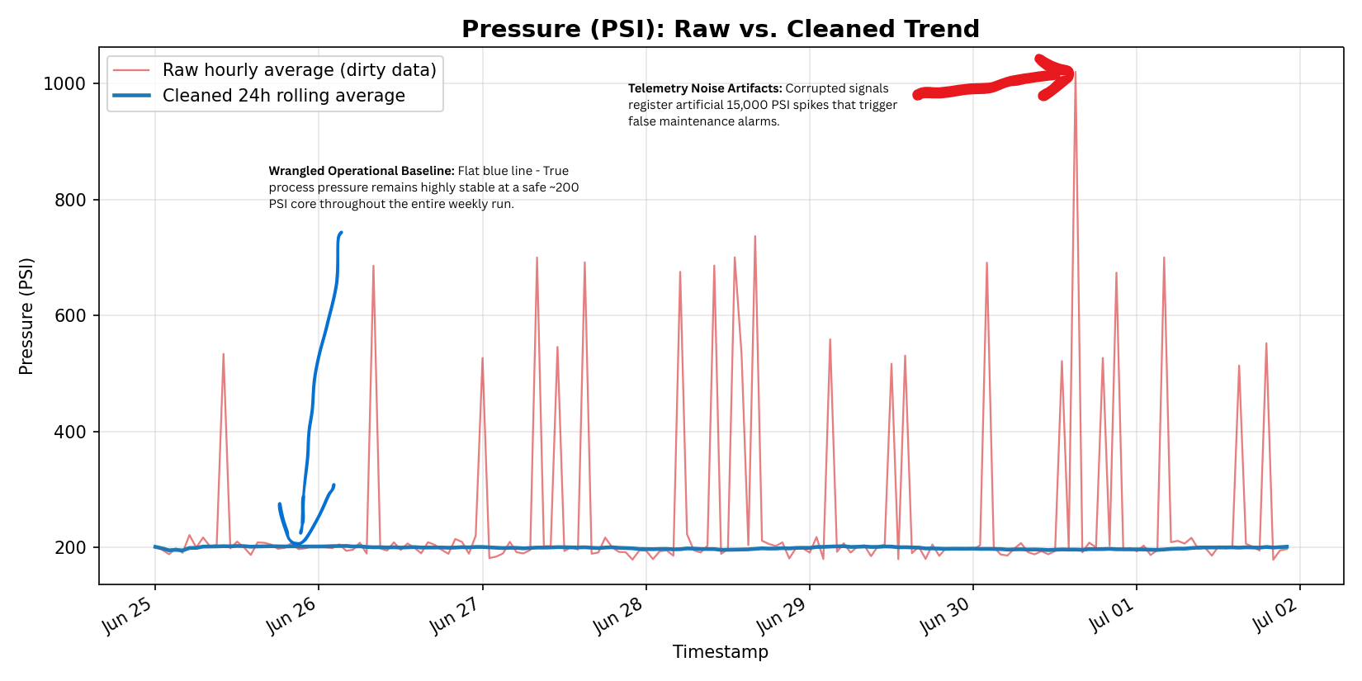Fig 1: Pressure (PSI) Baseline Stabilization via Telemetry Cleaning Pipeline

- Insight: Unmasking Total Process Stability
By filtering out this severe electronic signal noise and applying chronological statistical smoothing, we have uncovered the true physical state of our fluid systems. As displayed in the attached visualization, our core lines are actually operating with excellent structural stability. Fluid pressure is holding steady near a safe, normal baseline of 200 PSI across the entire week, proving that our pressure safety valves are holding perfectly. However, removing this noise has revealed a distinct pattern: during the Night Shift, core fluid temperatures drop significantly, running an average of 16.7°C cooler than the Morning and Afternoon shifts. This consistent shift drop was entirely buried beneath the raw sensor noise.

- Action: Mandatory Grounding Audit And Shift Review
Because our cleaned metrics prove that our physical pressure valves are completely stable, we can avoid expensive mechanical maintenance shutdowns. Instead, I recommend taking two immediate, targeted actions to fix our monitoring systems and investigate shift patterns:
- Dispatch an Instrumentation Crew: Within the next 24 hours, inspect the digital I/O lines and sensor grounding wires. The massive 15,000 PSI spikes point directly to electrical interference or poor line shielding corrupting our digital signals.
- Audit Night Shift Operations: Review the night crew's operational logs to determine why line temperatures drop so sharply overnight. We must verify if technicians are manually adjusting coolant flow or changing boiler baselines to speed up cleaning cycles during low-supervision hours.

